**EXPERIMENT-10**

**NEXUS INTEGRATION WITH JENKINS**

Name: Aditya Agarwal  
Rollno:R171218007  
Sap id: 500069294

open Jenkins and download the plugins

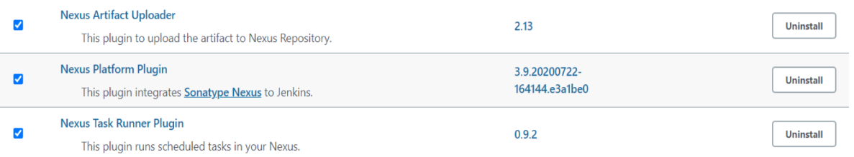

Go to global configuration tool and add jdk path

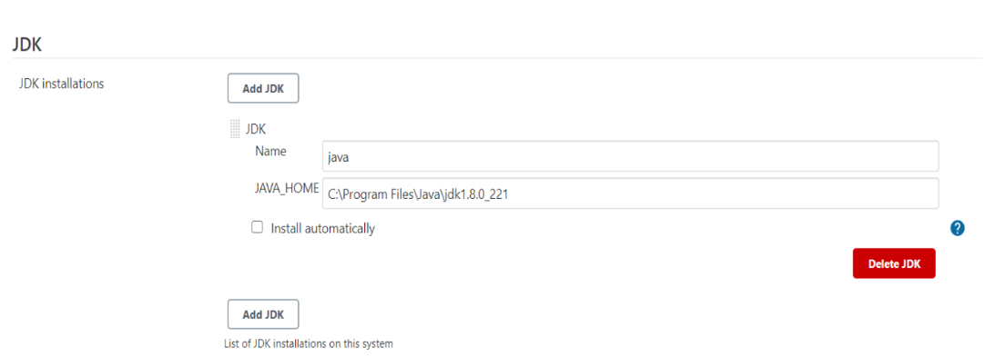  
  
Add path

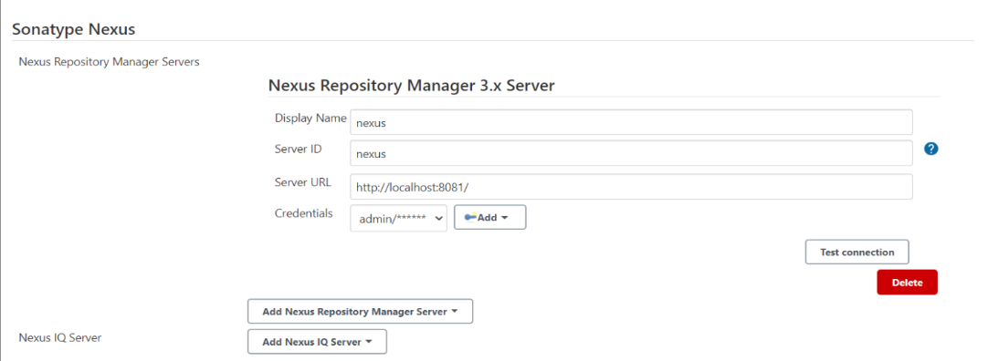

Create a job to deploy the project on server

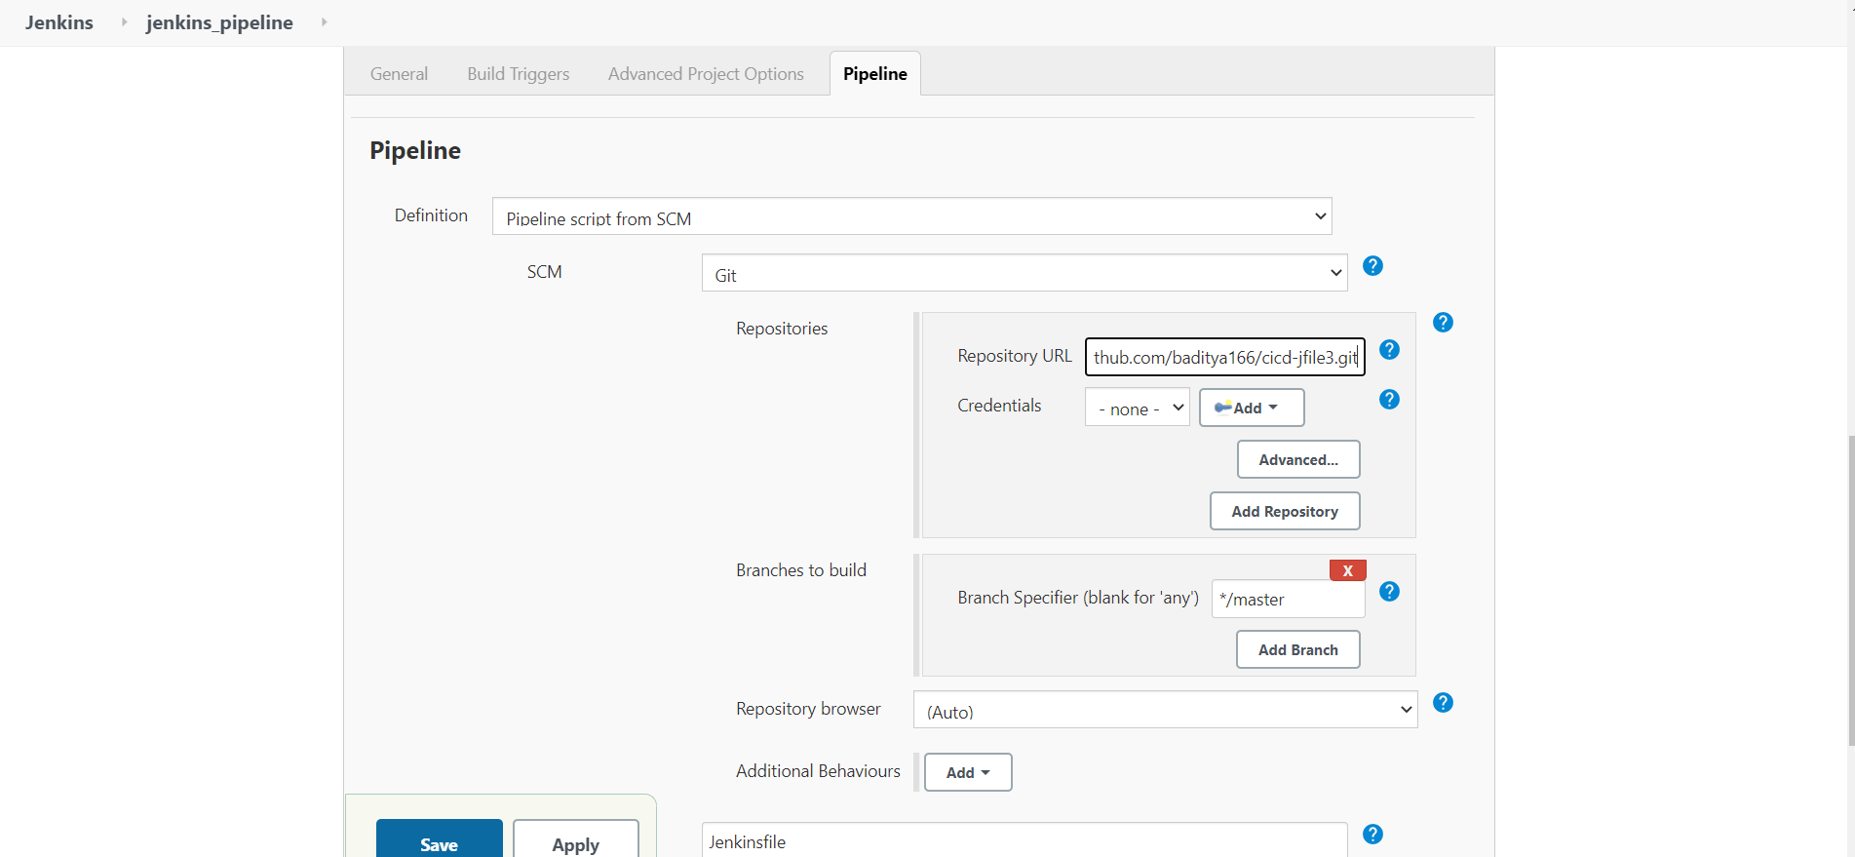

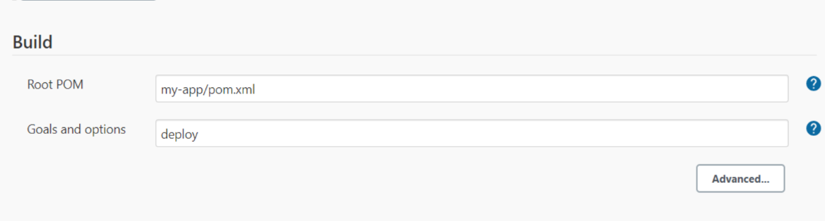

Console output

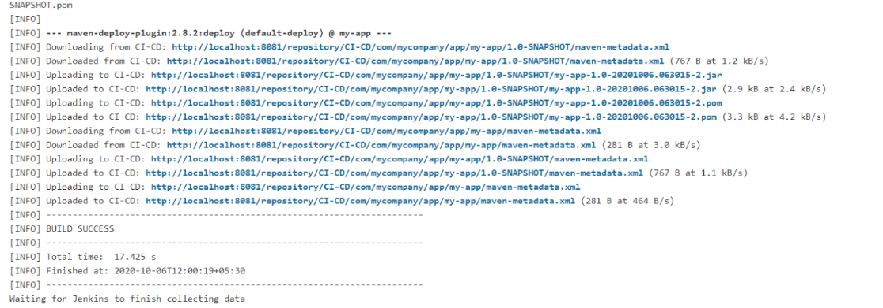

Project on nexus server

